**COMET BAY COLLEGE**

**Physics - Unit 2 - Task 8**

**Practical Exam**

**Name: SOLUTIONS Total Marks /60**

Note: Show working for all mathematical answers.

**Question 1**

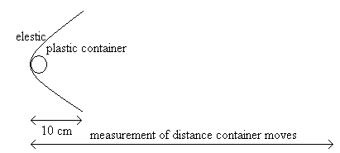

*Figure 2*

Rachael is conducting an experiment to find out how the weight effects the distance a plastic container can travel along a mostly smooth surface.

She clamps a piece of elastic across a desk and pulls it back 10 cm. She measures this distance using a ruler that measures in millimetres. She places a plastic container on a scale that measures at 100 gram intervals and finds that the container weighs 0.1 kg. She holds the container with the elastic before releasing the elastic. The plastic container slides along the surface until it stops and the distance was measured. The experiment was repeated twice more. See Figure 2.

She then repeated the experiment using 0.2 kg, 0.3 kg, 0.4 kg and 0.5 kg weighted containers.

**mass added (kg)**

**distance travelled (m)**

a) (i) State the independent variable: __________________________________ **(1 mark)**

(ii) State the dependent variable: _­___________________________________ **(1 mark)**

(iii) List two controlled variables: **(2 marks)**

**Answers include:**

**Same distance container pulled back (10 cm),**

**Same surface container slides on,**

**(need at least 2 for 2 marks)**

b) Write the prediction component only for the hypothesis for this experiment. **(2 marks)**

________________________________________________________________________________________________________________________________________________________________________________________________________________________________________________________________________________________________________

**As the mass is increased, the distance the container travels is decreased. (1 mark)**

**The relationship will be inversely proportional in that as the mass is doubled the distance travelled is halved. (1 mark)**

c) List two uncertainties that could be considered in this experiment? Name the uncertainty (error) and assign a ± value of the uncertainty based on the information given above

**(2 marks)**

**Mass ±0.05 kg. (1 mark)**

**Length ±0.0005 m. (1 mark)**

d) She collected her results and recorded them below. Complete the table. **(4 marks)**

|  |  |  |  |  |  |
| --- | --- | --- | --- | --- | --- |
| **Total weight (kg)** | **Distance travelled (m)** | | | **AVERAGE (m)**  **0.46 m ± 0.0005 m**  **0.40 m ± 0.0005 m**  **0.32 m ± 0.0005 m**  **0.29 m ± 0.0005 m**  **0.26 m ± 0.0005 m**  **0.20 m ± 0.0005 m** | **±uncertainty** |
| **Trial 1** | **Trial 2** | **Trial 3** |
| 0.1  **Marks:**   * **calculated averages (1 mark)** * **converting to SI units (1 mark)** * **not using the value weight 0.6kg, trial 2 of 10cm in average (1 mark)** * **for correct ±uncertainty (1 mark)** | 0.49 | 0.43 | 0.46 |  |  |
| 0.2 | 0.37 | 0.40 | 0.42 |  |  |
| 0.3 | 0.32 | 0.33 | 0.31 |  |  |
| 0.4 | 0.29 | 0.32 | 0.27 |  |  |
| 0.5 | 0.25 | 0.25 | 0.27 |  |  |
| 0.6 | 0.19 | 0.10 | 0.21 |  |  |

**Question 2**

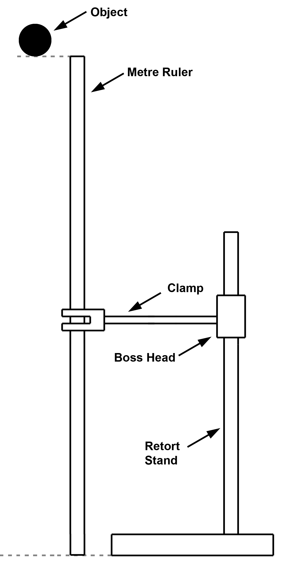

*Figure 1*

Two students were carrying out an experiment where the aim was to investigate the possible relationship between Gravitational Potential energy and Kinetic Energy. This was achieved by dropping an object from a height of one metre (*Figure 1*) and recording the speed of that object at select intervals before impact using a data-logger.

In carrying out the experiment, the students obtained the following set of data, as shown below:

|  |  |  |
| --- | --- | --- |
| Mass of ball (g) | Height at where speed was recorded **(from start point)** | Speed (m s-1) |
| 150.0 g | 15 cm | 0.984 |
| 150.0 g | 35 cm | 2.099 |
| 150.0 g | 55 cm | 2.827 |
| 150.0 g | 75 cm | 3.412 |
| 150.0 g | 95 cm | 3.840 |

a) Calculate the Gravitational Potential energy (Ep) and the Kinetic energy (Ek) at the initial point of release. **(4 marks)**

**Ep = mgh**

**= 0.15 x 9.8 x 1 (1 mark)**

**= 1.470 J (1 mark)**

**Ek = ½ mv2**

**= ½ x 0.15 x 02 (1 mark)**

**= 0 J (1 mark)**

From the data collected the students decided to produce a new table that would better explain the energy transformations. Complete the following table. This new table shows the **heights from the base**.

**Minus 1 mark each column, minus 1 mark rounding**

b) Complete the table **(5 marks)**

|  |  |  |  |  |
| --- | --- | --- | --- | --- |
| Height from base (m) | Potential Energy (J) | Speed (m s-1) | Kinetic Energy (J) | Mechanical Energy (= KE + PE) (J) |
| 1.00 |  |  |  |  |
| 0.85 |  |  |  |  |
| 0.65 |  |  |  |  |
| 0.45 |  |  |  |  |
| 0.25 |  |  |  |  |
| 0.05 |  |  |  |  |

**1.470**

**1.323**

**1.29**

**1.26**

**1.24**

**1.18**

**0**

**0.073**

**0.330**

**0.599**

**0.873**

**1.106**

**0**

**0.984**

**2.099**

**2.827**

**3.412**

**3.840**

**1.470**

**1.25**

**0.956**

**0.662**

**0.368**

**0.0735**

c) For the results obtained in the Mechanical Energy section, explain whether this is what you would expect and why. **(3 marks)**

____________________________________________________________________________________________________________________________________________________________________________________________________________________________________________________________________________________________________________________________________________________________________________________________________________________________________________________________________________________________________________________________________________________________________________________________________________________________________________________________________________________________________________________________________________________________________

**Under pure conditions (e.g. air resistance is negligible) Mechanical Energy should be constant. (1 mark)**

**This is not seen and in fact the Mechanical Energy is decreasing, (1 mark)**

**most likely due to the external factors (e.g. air resistance).**

**Part (a) and under pure conditions Mechanical Energy should be 1.470 Joules (1 mark)**

d) What conclusion can be made relating to the aim of the experiment based on the data obtained? **(2 marks)**

____________________________________________________________________________________________________________________________________________________________________________________________________________________________________________________________________________________________________________________________________________________________________________________________________________________________________________________________

**Relationship between Gravitational Potential energy and Kinetic Energy not conclusively evident. (1 mark)**

**Within the experiment, an error where Ep + Ek not equal due to factors such as air resistance. (1 mark) or similar**

**Question 3**

A student rolled a toy car down a ramp. The ramp was 4.0 m long and the student placed the ramp at an angle to the desk. He then marked off sections of the ramp to show when he would record the displacement and time (See Figure 1: Ramp). He also noted that in the first 2 seconds the toy car experienced acceleration before continuing down the ramp at constant velocity.

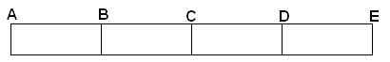

*Figure 1: Ramp*

He obtained the results shown below:

|  |  |  |  |  |  |
| --- | --- | --- | --- | --- | --- |
| Sections of Ramp | A | B | C | D | E |
| Total displacement from start (m) | 0 | 1.0 | 2.0 | 3.0 | 4.0 |
| Total time (s) | 0 | 3.16 | 5.61 | 8.04 | 10.52 |

1. On the graph below, graph the total distance versus total time and draw a line of best fit starting at 2 seconds. Also sketch the acceleration component on the graph for the first 2 seconds **(5 marks)**

**Marks:**

title (½ mark), axis correct (½ mark each)

axis labelled (½ mark each) point plotted (1 mark, -½ mark each mistake)

line of best fit – needs to show curve at start and then a straight section (1 mark)

x – axis is independent axis (½ mark)

b) Use the graph to calculate the gradient of the line between 2.0 m and 4.0 m. Show coordinates used and units of measurement. **(3 marks)**

**gradient = $\frac{rise}{run}$ = $\frac{2}{5}$ (1 mark)**

**gradient = 0.4 m s-1**

**(1 mark) (1 mark)**

**Question 4**

Read the information below then answer the following questions.

**Background Information:**

The period of a pendulum can be found using the following equation:

T = 2 $π\sqrt{\left(\frac{l}{g}\right)}$ where T = period of oscillation (swing back and forth)

ℓ= length of the string

g = acceleration due to gravity; 9.8 ms-2

***Hypothesis:***

*The period of oscillation of a pendulum is independent of the mass on the pendulum, therefore if the mass is increased, the period will remain constant within experimental error.*

* + - * 1. Jane conducted the experiment to investigate if the hypothesis above was true by increasing the mass and measuring the period for each different mass. Her results are recorded in the table below.

Length of string: 82.6 cm

|  |  |  |  |  |
| --- | --- | --- | --- | --- |
| **Mass** | **Time for 10 complete swings** | | **Average for 10 swings** | **Period** |
| **Trial 1** | **Trial 2** |
| 150g | 17.23 | 19.03 | **18.13 1.813**  **18.27 1.827**  **18.17 1.817** |  |
| 200g | 18.68 | 17.86 |  |  |
| 300g | 18.21 | 18.13 |  |  |

1. Complete the table above. **(3 marks)**
2. What is the average period for the different masses (no working required)? **(1 mark)**

**T = 1.819 s (1 mark)**

1. Determine the theoretical time period for the pendulum. **(2 marks)**

**T = 2 $π\sqrt{\left(\frac{l}{g}\right)}$**

**T = 2 × $π\sqrt{\left(\frac{0.826}{9.8}\right)}$ (1 mark)**

**T = 1.824 s (1 mark)**

* + - * 1. What is the percentage error between the practical and theoretical results? **(2 marks)**

**%error = × 100 (1 mark)**

**%error = 99.7 % (1 mark)**

* + - * 1. Write a discussion for this experiment. **(10 marks)**

______________________________________________________________________________________________________________________________________________________________________________________________________________________________________________________________________________________________________________________________________________________________________________________________________________________________________________________________________________________________________________________________________________________________________________________________________________________________________________________________________________________________________________________________________________________________________________________________________________________________________________________________________________________________________________________________________________________________________________________________________________________________________________________________________________________________________________________________________________________________________________________________________________________________________________________________________________________________________________________________________________________________________________________________________________________________________________________________________________________________________________________________________________________________________________________________________________________________________________________________________________________________________________________________________________________________________________________________________________________________________________________________________________________________________________________________________________________________________________________________________________________________________________________________________________________________________________________________________________________________________________________________________________________________________________________________________________________________________________________________________________________________________________________

**Discussion**

* **Summary of results direction**
* **(including numerical values)**
* **Relates results to hypothesis**
* **Ties in variables**
* **Discusses controlled variables and;**
* **Discusses other unforseen variables that created errors.**
* **Method of improving/removing errors is clear and does not include vague environmental factors or personal factors**

**(3 marks) Minimum 3 errors and methods of improvement mentioned. (-1 for every error not mentioned)**

**Question 5**

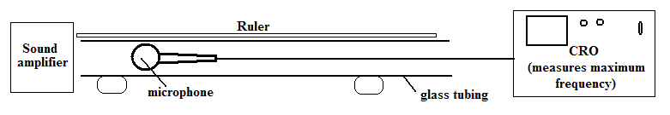Samantha was trying to find the speed of sound within an open tube. She set up the equipment shown and recorded the distances between maximum frequency readings using the cathode ray oscilloscope (CRO). She recorded her results in the table below.

|  |  |  |  |  |  |  |  |  |  |  |  |  |  |  |  |  |  |  |  |  |  |  |  |
| --- | --- | --- | --- | --- | --- | --- | --- | --- | --- | --- | --- | --- | --- | --- | --- | --- | --- | --- | --- | --- | --- | --- | --- |
| **Frequency**   |  |  |  |  | | --- | --- | --- | --- | | **Frequency**  **(Hz)** | **Distance between maximum freq. (cm)** | **Wavelength**  **(m)** | **Speed of sound (ms-1)** | | 200 | 84.5 | **1.69** | **338** | | 500 | 68.0 | **1.36** | **680** | | 800 | 21.2 | **0.424** | **339.2** | | 1100 | 15.4 | **0.308** | **338.8** |   **(Hz)** | **Distance between maximum freq. (cm)** | **Wavelength**  **(m)** | **Speed of sound (ms-1)** |
| 200 | 84.5 |  |  |
| 500 | 68.0 |  |  |
| 800 | 21.2 |  |  |
| 1100 | 15.4 |  |  |

1. Complete the wavelength column in the table showing your calculations for 200 Hz below.

**λ = 2 x **

**= 2 x 0.845 (1 mark)**

**= 1.69 m (1 mark)**

**(3 marks – 2 marks for 200 Hz calculations and 1 mark for all others shown in table)**

1. Show your calculation for the speed of sound for 200 Hz below, then complete the last column in the table.

**(3 marks – 2 marks for 200 Hz calculations and 1 mark for all others shown in table)**

**v = λf**

**= 1.69 x 200 (1 mark)**

**= 338 m s-1  (1 mark)**

1. What value did Samantha get for the speed of sound? **(2 marks)**

**(338 + 339.2 + 338.8) ÷ 3 (1 mark)**

**= 338.67 m s-1 (1 mark)**

**(if have 424 m s-1, only 1 mark)**